Subject: Global Studies I
Benchmark: Parthenon
Standards: 2A, 2B, 2C, 3A

TOPIC: Early People of the Aegean and the Rise of Greek City-States

MAJOR IDEA: In the centuries preceding the heyday of Greek civilization, early cultures thrived and lay the groundwork for the golden age of Greece. It was the Myceneans, an ancient people of the Greek mainland who first developed city-states. Although the Mycenean civilization was destroyed and Greece endured a dark period, eventually it was the rise of the city-states such as Sparta, Crete, Delphi, Athens, and Rhodes that created the foundation for the glorious ages of Pericles, Alexander, and the Hellenistic Age.

SUGGESTED AIMS:
- Where is the Aegean region? What are its borders and principal geological features? What modern countries does the Aegean region comprise?
- Who were the Minoans? What were the characteristics of their culture? What happened to them?
- Who were the Myceneans? What were the characteristics of their culture? What happened to them?
- What is a city-state? How does a city-state function? As a system of government, what is the difference between a city-state and a monarchy? Between a city-state and a theocracy? Between a city-state and a dictatorship? And an oligarchy? And an aristocracy? How does a city-state compare to a democracy?

VISUAL EXAMPLES:
- Image of the Parthenon
- Image of the Palace at Knossos

SUGGESTED ACTIVITIES:
- Compare and contrast the architecture of the Parthenon and the Minoan Palace at Knossos. Which architectural elements are the same? Which are different? How do the materials compare? What type of decoration appeared on each building? (e.g., frieze, mosaic.) Which building is more sophisticated? Why? What building techniques were used for each? What role did geography play in the construction of each building? Students may construct a model of each building.
- Create a diagram indicating how the spaces of each building were used. Students can draw the floor plan of each building. What relationship did each building’s use have to the political and religious systems of Minoa and Periclean Greece?
- Research the meaning and symbolism of the images on the Parthenon frieze, the Parthenon metopes, and the frescoes and mosaics of the Palace at Knossos. What are the differences? What are the similarities? What are the subjects of the imagery? Myths? Epic tales? Historic figures?
- Make a fresco, a mosaic, or a sculpted tablet in low relief (such as the Parthenon’s frieze or metopes) that depicts a favorite Greek myth.
- Study the origin of the word “polis.” What does it mean? Why is the Parthenon located on the Acropolis? What does “Acropolis” mean?
- Brainstorm and then research other examples of governments throughout history that were based on the city-state model. Ideas include the Italian city-states and the American federation of states.
- Create an annotated map of the Greek city-states. Next to each city-state, students can list the city-states principal building sites, names of principal leaders, and contributions to art and literature.

RESOURCES:
- http://emuseum.mnsu.edu/prehistory/aegean/maps.html Ancient Aegean maps that show patterns of immigration of Aegean peoples.
- http://devlab.dartmouth.edu/history/Bronze_age/ Prehistoric archaeology of the Aegean. Features a chronology and an explanation of terminology. Ancient Aegean cultures explored in 29 different chapters or “lessons” that go back to the Paleolithic era.
- http://www.wsu.edu:8080/~dee/GLOSSARY/POLIS.HTM History of the Greek City-State.
- http://killeenroos.com/1/sparath.htm Comparison between various aspects of Spartan and Athenian societies and cultures. Worksheet for students.
- About:blankhttp://www.geocities.com/capitolhill/9054/greek.html Flags of Greek City-States. Includes Athens, Crete, Palasgians, Delphi, Rhodes, and Sparta.

HOMEWORK:
- Write an essay comparing the Greek city-states and state governments in the United States. Which was more powerful? Why? Which system is more truly democratic?
- Ask students to consider the Mycenean and Minoan influences on later Greek civilization. Have students write an essay describing the legacy that these societies left to the Periclean Greeks in terms of: politics; art; religion; language; architecture; literature; commerce; trade.
- What do the images in the frieze of the Parthenon teach us about daily life in Greece? What are the types of activities, clothing and interactions that are detailed there? Ask students to research some aspect of daily life in ancient Greece and then create a model of a frieze panel which illustrates this aspect of Greek life.

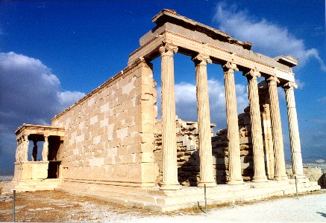
The Parthenon

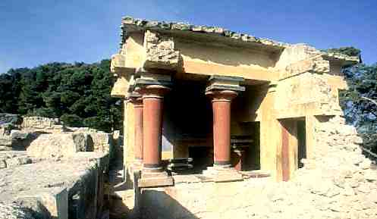
The palace at Knossos

